Introduction

5V Supply is needed for RGB LED-s and relays. 3,3V Regulator supply also originates from 5V supply.
Load | Current [mA]
10 RGB LED-s | 10
8 relays | 644
3,3V SMPS 80% efficiency | 396
Total | 1050

Maximum input voltage of the system is 32V. SMAJ33A has a reverse working voltage of 33V and maximum reverse voltage 53,3V at 7,5A surge current.
The regulator input should be 54 V tolerant.

Regulator selection
LM46002AQPWPRQ1 was selected from Krakul library. Vin is 60V and maximum output current is 2A. It has been used in multiple circuits earlier.

Schematic design
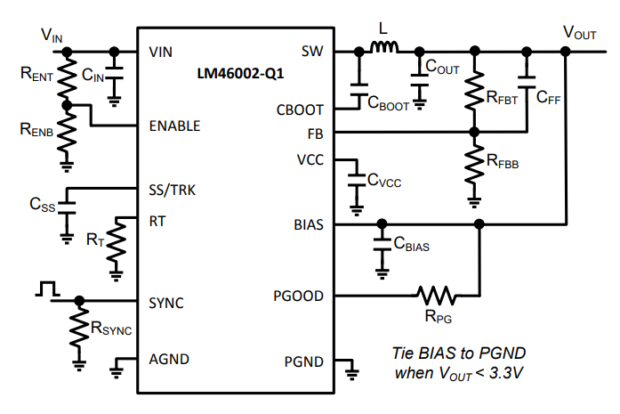
Figure 1: Typical application
Datasheet gives multiple application examples.
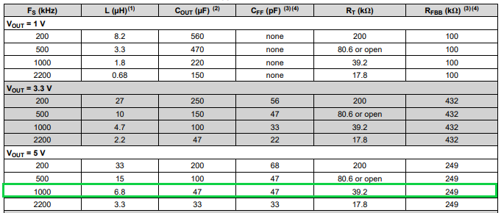

1 MHz switching frequency is selected as a compromise between switching losses and component sizes.
Suggested bootstrap capacitor C_{BOOT} is 470nF.

VCC pin is the output of the internal LDO. C_{VCC} should be 2,2µF and at least 10V rated.

To increase light load efficiency BIAS will be connected to regulator output. BIAS is the input of the internal LDO. The smaller the input output voltage difference the better the efficiency. 1uF capacitor is suggested close to the pin as the input capacitor of the LDO.

Soft-start capacitor will not be used. When the pin is floating the soft start time is 4,1ms. This seems reasonable and the same choice has been made in other implementations.

SYNC pin will not be used, and it will be tied to GND.

Additional 100nF capacitor is added to the regulator output to suppress switching noise at higher frequencies.

For input capacitor datasheet suggests using 10uF. Three 4,7nF 100V 1210 capacitors were used. 100V helps mitigating capacitance drop due to DC bias.

